AGENT SELECT

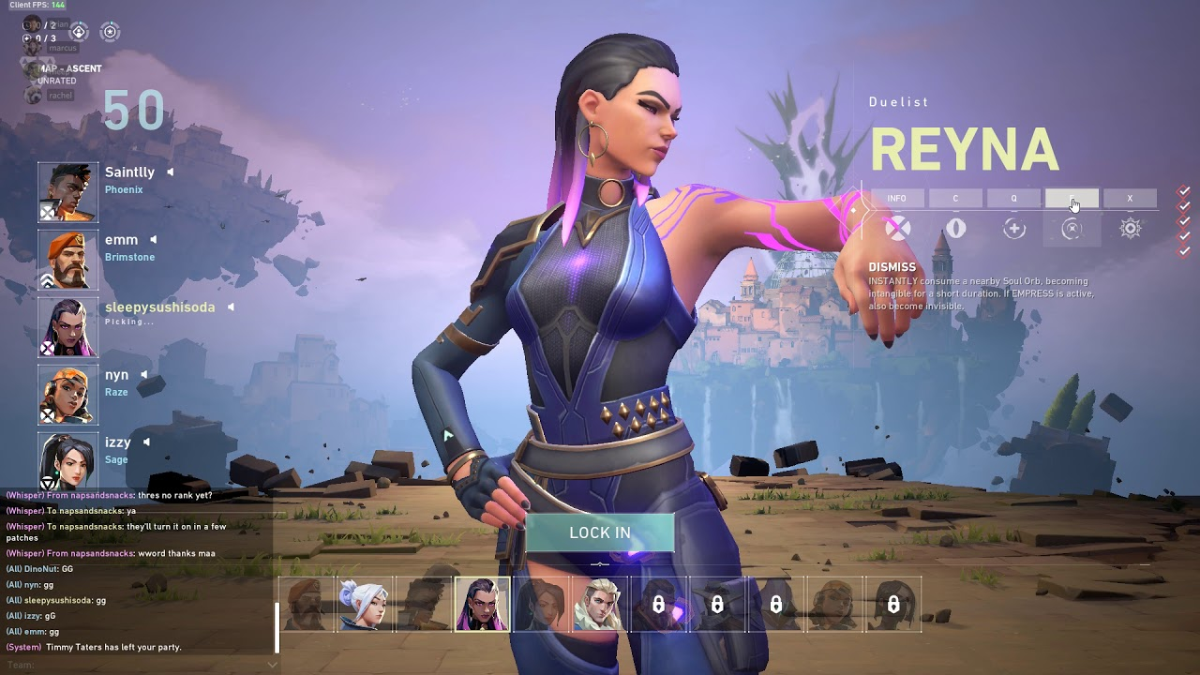

This is one of the most basic game feature in Valorant and hence I would start this feature first.

The player can choose from a set of agents and a timer of 60 seconds start. No 2 player can have the same agent. So the first player to lock in gets the agent . If the player have selected an agent but haven’t locked in the timer will reach till 0 seconds and then the game will start. If any of the player didn’t select the agent the match will be over.

Problem: How to store Values

Solution 1: Storing values as Integer for Each Agent

Solution 2: Using Bit masking

We also have to store the agent for each player for now lets

Solution 1 could take less space for small scale but for large scale it will take more space than bit masking.

Case1: Total number of current games:

Case2: Total number of Current games: 1000

Using Solution 1: Total players: 1000\*10=10000

Integer Size: 4 bytes

Total Size: 10000\*4=40000 Bytes

Using Solution 2: Only One integer used to store : 4bytes

Integers to store

I have decided to do this project in